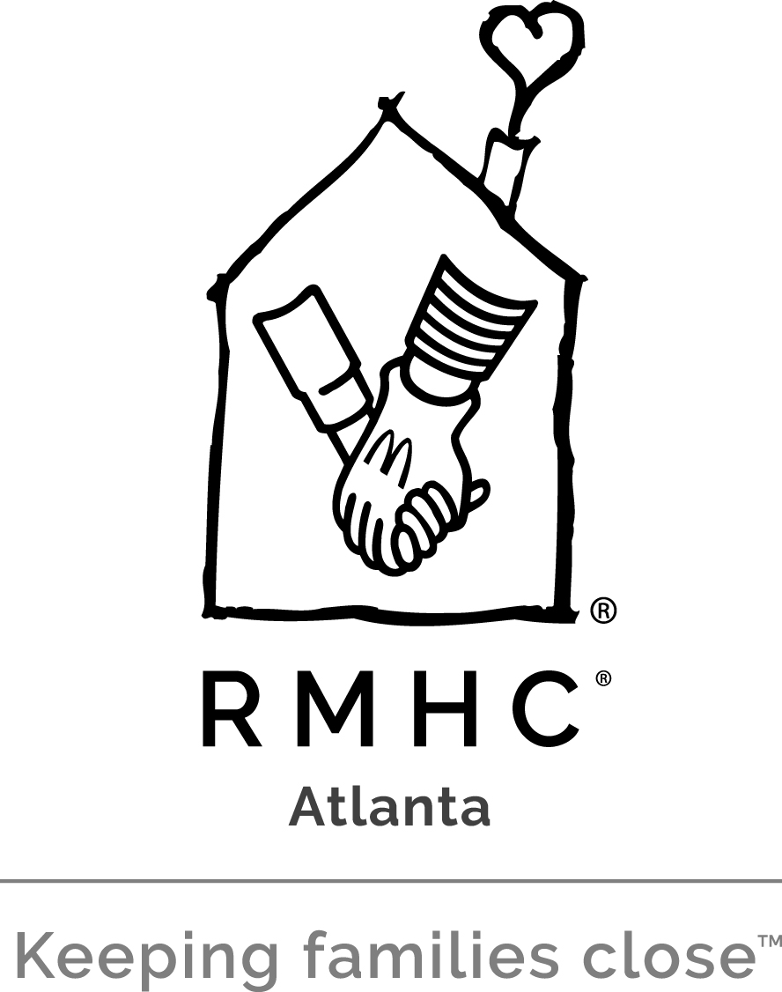

ATLANTA RONALD McDONALD HOUSE CHARITIES (ARMHC)

Job Title: Marketing & Communications Manager

Job Purpose:
The Marketing & Communications Manager plays a primary role within ARMHC by leading marketing, social media and revenue building initiatives to raise awareness of and increase understanding for our mission. Position reports to the Marketing & Communications Director.

Qualifications:
- Bachelor’s Degree in Advertising, Communications and/or Marketing with a minimum of four years’ experience. Clear knowledge of non-profit compliance and mission of ARMHC.

- Strong computer skills and knowledge of Microsoft Office Suite (Word, Outlook, Excel, PowerPoint). Proficient in use of MAC environment with working knowledge of desktop publishing software programs including Illustrator, InDesign, Photoshop, QuarkXPress and Publisher. Experience with WordPress, CSS, Dreamweaver and HTML is a plus.

- Strong project management skills, self-motivated with ability to work under pressure and meet deadlines in a fast-paced environment.

- Excellent writing, editing and communication skills, including an engaging written voice.

- Requires prompt performance and strict attention to detail and ability to work independently.

- Knowledge of business protocol; excellent organizational and interpersonal skills; and be able to prioritize while completing multiple assignments.

- Excellent communication, presentation, assessment, problem solving, organizational and time management skills.

- Available to work long hours, including evenings and weekends as needed, to complete goals and activities.

- Characteristics: dependability, tactfulness, honesty, trustworthiness, flexibility and professionalism.

Essential Functions:
- Digital Marketing/Website Management
- Develop compelling content and photos to feature families, donors and volunteers
in e-mail blasts, e-newsletters, blog posts and e-mail appeals on a monthly basis to
promote fundraising/PR initiatives.
- Design creative for digital campaigns for social media ad internet advertising campaigns
- Add and update engaging content and photos to website on an ongoing basis
- Collaborate with special events team to update all special events content including: Atlanta/Brookhaven Dines In, Brookhaven Tour of Homes, Handbag Hullabaloo, 5K Race & Fun Run, Hearts and Hands Gala, BMW Raffle and Golf Tournament.
- Work with each department to secure ongoing content for specific web pages (ex: scholarship page, volunteer page, etc.) and ensure website stays up to date.
- Responsible for maintaining relationship with BlackBaud concerning all Online Express Digital Marketing initiatives.
- Ensure copyrighted materials are up-to-date (footer, templates, etc.)
- Responsible for managing relationships and workflows with outsourced PR/marketing consultants and/or web developers.

Social Media
- Develop compelling content for social media campaigns to build followers and increase understanding of ARMHC’s mission.
- Manage ARMHC’s on-line presence by monitoring all ARMHC social media channels on a daily basis (e.g. Facebook, Instagram, Twitter, LinkedIn, Pinterest, blog posts.) Remove spam and/or inappropriate content in a timely fashion.
- Post engaging content and photos for all social media outlets in a timely manner.
- Identify and follow influential users and high profile individuals to encourage support.
- Monitor results and analyze social media trends.

- Marketing and Communications
- Develop and execute annual communications plan and messaging calendar with input from all ARMHC departments.
- Responsible for executing and designing direct mail appeals and assets with Development Team.
- Responsible for ensuring the integrity of Global RMHC brand standards on all ARMHC communications material.
- Responsible for managing relationships and workflows with outsourced creative designers, PR/marketing consultants and agencies.
- Responsible for the local Chapter execution of all Global RMHC campaigns and utilizing marketing resources available through RADAR.
- Manage the execution PR and brand awareness campaigns by drafting copy for collateral necessary for the successful achievement of ARMHC communications goals including: brochure copy, media advisories, fact sheets, press releases, photo captions, bios, PSA and web copy, e-newsletter articles or other promotional materials.
- Recruit and supervise intern.
- Develop and maintain media lists and databases.
- Responsible for ensuring all press clips are compiled.

- Special Events
- Ensure all pertinent information regarding special events (e.g. ARMH Golf Classic and BMW raffle) is entered into the Raiser’s Edge (RE) database in a timely manner. Gifts must be entered into R.E. as soon as the donation/sponsorship is communicated to ARMHC.
- Identify and confirm a minimum of 15 promotional events for the BMW raffle.
- Process all accounting procedures, licenses, liability/insurance forms, and related documents necessary for BMW raffle.
- Design invitations and collateral for special events.
- Assist special event staff as needed on all other ARMHC special events (e.g. Golf Classic, Handbag Hullabaloo, Atlanta/Brookhaven Dines In, Brookhaven Home Tour, Hearts and Hands Gala, 5K Race & Fun Run).

Other Functions:
- Assist with mailings, filing, copying and other administrative tasks.
- Attend meetings and functions as designated by President & CEO.
- Fill speaking engagement requests when appropriate.
- Local travel in a 90-mile radius to meetings, appointments and constituent relations as needed.

Disclaimer:
This is not necessarily an exhaustive list of all responsibilities, skills, duties, requirements, efforts or working conditions associated with the position. While this is intended to be an accurate reflection of the current position, management reserves the right to revise the position or to require that other or different tasks be performed when circumstances change (i.e. emergencies, changes in personnel, workload, rush job, or technological developments).

Physical Demands
- Maintain a workspace within Administrative Offices of ARMHC.
- Near visual acuity essential for reading.
- Talking and hearing essential for communication.
- Physically able to climb stairs.
- Physically able to transport items up to 50 pounds necessary to set-up events.
- Travel

Responsibility:
The Marketing & Communications Manager is directly responsible to the Marketing & Communications Director of Atlanta Ronald McDonald House Charities and is evaluated annually.

Approved: ________________________ ______ ____________________
Marketing & Communications Director Date

Accepted: ______________________________ ____________________
Marketing & Communications Manager Date

Revised March 2018

