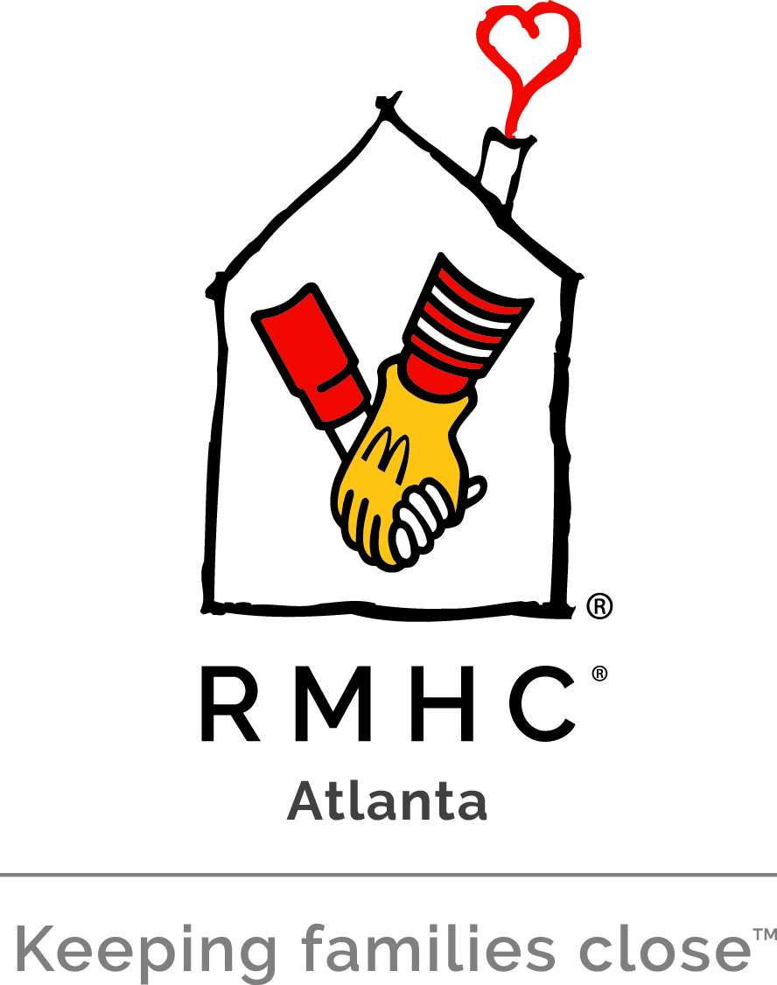

Job Title: Special Events Coordinator

Job Purpose:

The Special Events Coordinator is integral to the success of Atlanta Ronald McDonald House Charities (ARMHC) and plays a vital role in advancing the goals of the Development Department. This position reports directly to the Director of Special Events to help ensure all events are successful and goals are met, with a focus on the management and execution of specific assigned special events, third party events, the Red Shoe Society and Future Leaders Board (Young Professionals), and providing support to the Director for signature annual events. The Special Events Coordinator is responsible for coordinating and growing the events in their portfolio. This position requires flexibility, excellent written and verbal communication skills, attention to detail, high energy and a passion for ARMHC and its mission.

Qualifications and Job Requirements:

- Bachelor’s Degree in non-profit management or related field such as communications, public relations, marketing or business and a minimum of two years of proven experience within the non-profit sector in the areas of fundraising required. Experience with special events a plus.

- Exceptional project management skills with strong ability to manage multiple projects and meet multiple deadlines.

- Excellent writing, editing, and presentation skills.

- Ability to take direction and work independently.

- Ability to think creatively to grow special events in portfolio.

- Experience managing, inspiring and leading volunteer event committees with demonstrated successful outcomes a plus.

- Experience with donor stewardship activities and ability to build and strengthen existing relationships and secure new event sponsors.

- Experience creating and managing special event budgets a plus.

- Excellent computer skills and knowledge of Microsoft Office Suite with strong ability in Excel and PowerPoint; Experience with Raiser’s Edge or other donor databases is a plus.

- Ability to work evenings and weekends as needed, to execute events and reach goals.

- Possess the following characteristics: compassion, tact, honesty, trustworthiness, flexibility, and professionalism.
Duties and Responsibilities:

Special Events

Brookhaven Tour of Homes
The biennial Historic Brookhaven Candlelight Tour of Homes features Brookhaven’s most impressive and beautifully decorated homes. This is a one-night event showcasing five to seven homes.
- Manage volunteer event committee and attend committee meetings
- Oversee creation of collateral materials
- Lead sponsorship and ad sales for the event program
- Create and manage event budget
- Create communication plan to promote event
- Steward event sponsors

Brookhaven Dines In
The biennial Brookhaven Dines-In is a series of exclusive dinner parties hosted in private homes with cuisine prepared and served by local chefs.
- Manage volunteer event committee and attend committee meetings
- Recruit restaurant donations
- Oversee creation of collateral materials
- Create and manage event budget
- Create communication plan to promote event
- Steward event sponsors

Third Party Events
- Oversee all third party fundraising events including securing event applications and agreements and approving events.
- Work with ARMHC communications team to create and execute plans for event promotions.
- Track all events and enter appropriate information in donor database. Provide weekly tracking reports to VP of Development and Director of Special Events.
- Attend events as necessary and recruit volunteers as needed.

Red Shoe Society
- Serve as staff liaison and point of contact for all activities related to young professionals group.
- Lead fundraising efforts with the Red Shoe Society group; provide guidance to ensure successful events that meet revenue goals.
- Work with ARMHC communications team to create and execute plans for event promotions.
- Attend Red Shoe meetings and events as needed and where appropriate.

Future Leaders Board
- Serve as staff liaison and point of contact for all activities related to young professionals group.
- Lead fundraising efforts with the Future Leaders group; provide guidance to ensure successful events that meet revenue goals.
- Work with ARMHC communications team to create and execute plans for event promotions.
- Attend Future Leaders Board events and activities as needed and where appropriate.

Signature Events Support
Provide support to Director of Special Events with signature events including Hearts and Hands Gala, Annual Golf Classic and Handbag Hullabaloo.
- Manage sponsorship tracking
- Assist with mailings
- Work with ARMHC marketing team to ensure accurate and updated website pages for events and to create social media calendars and plans for each event
- Order collateral materials
- Solicit and track auction items
- Attend committee meetings as necessary

Other Functions:
- Fill requests for speaking engagement/awareness building opportunities
- Local travel in a 100-mile radius to attend meetings and events as needed
- Attend monthly Development team meetings and report on activities

Physical Demands:
Maintain an office within Administrative Offices of ARMHC Near visual acuity essential for reading
Talking and hearing essential for communication

Reporting Responsibility:

The Special Event Coordinator reports directly to the Director of Special Events of Atlanta Ronald McDonald House Charities and is evaluated annually.

Disclaimer:
This is not necessarily an exhaustive list of all responsibilities, skills, duties, requirements, efforts, or working conditions associated with the job. While this is intended to be an accurate reflection of the current job, management reserves the right to revise the job or to require that the other or different tasks be performed when circumstances change (i.e., emergencies, changes in personnel, workload, rush jobs, or technological developments).

To apply, send to Melinda Kelleher, vice president of development, a cover letter, resume, and three professional references with contact information including at least two people you have reported to. Application deadline is 5PM on Monday, June 3. Only applicants meeting qualifications will be considered. No walk-ins or phone calls please.

